Automating integration in Azure Resource

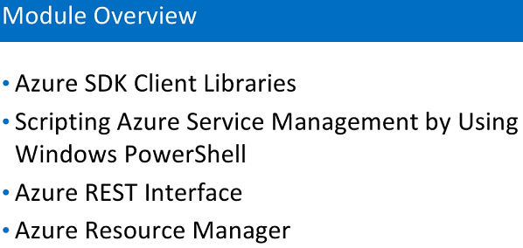

* **Automation Account**

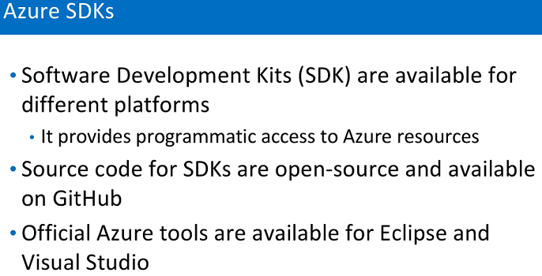

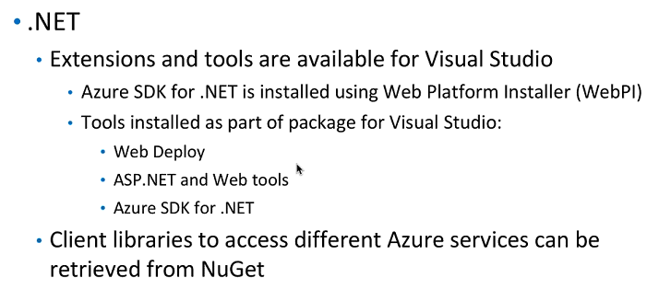

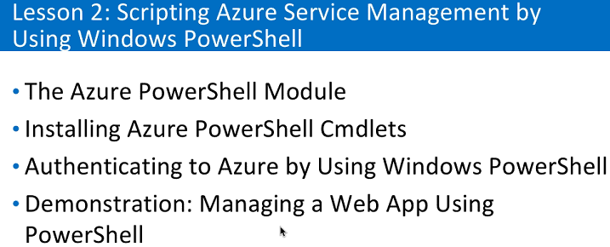

1. PowerShell is a powerful tool and it came with window 7 for client OS
2. Generally use for administration
3. Very reliable for remote administration
4. Use to manage my VM, app service, storage account , handle load balancer

Labs:

1. Create Virtual Machine
2. Open windows PowerShell SEI
3. Install window web PI
4. Go to server manager – local server – internet Explorer Enhanced Security Configuration – turn off
5. Open web platform installer
6. Install Microsoft azure PowerShell and Windows Azure Pack: PowerShell API
7. Update PowerShell
8. Run command Add-AzureRmAccount
9. Or
10. Open Powershell ISE
11. Run Add-AzureRmAccount

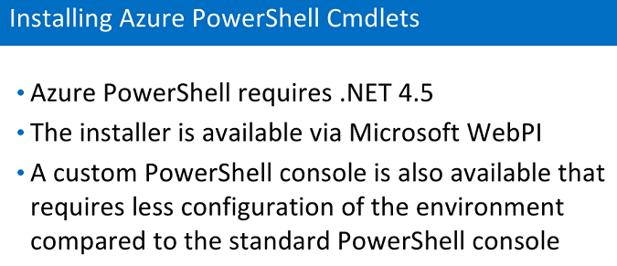

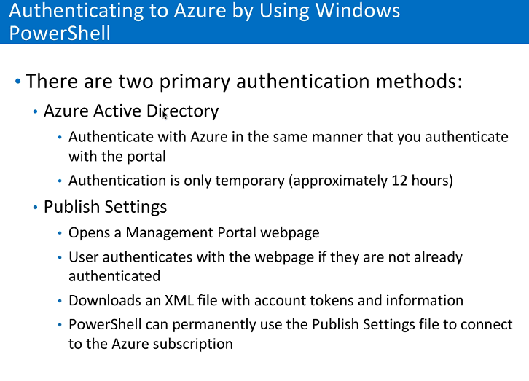

Labs:

PowerShell command:

Add-AzureRmAccount – to add sign in or create account in Azure.

Get-AzureRmSubscription – check for your subscription

Select-AzureRmSubscription -subscription "Free Trial" – this will select my Subscription

1. Create New Resource Group

New-AzureRmResourceGroup -Name "simplilearnRG" -Location 'Southeast Asia'

1. Create new App service Plan

New-AzureRmAppServicePlan -Name 'simpliLearnAppPlan' -Location 'Southeast Asia' -ResourceGroupName simplilearn -Tier Free

1. Create Web App

New-AzureRmwebApp -Name sipliLearwebApp -Location 'Southeast Asia' -ResourceGroupName simplilearn

Templates

Labs:

